Figure-1.1. Verilog Source code for 4-bit Counter
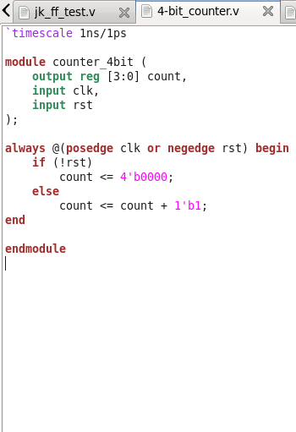

Figure-1.2. Verilog Source code for 4-bit Counter Test-bench
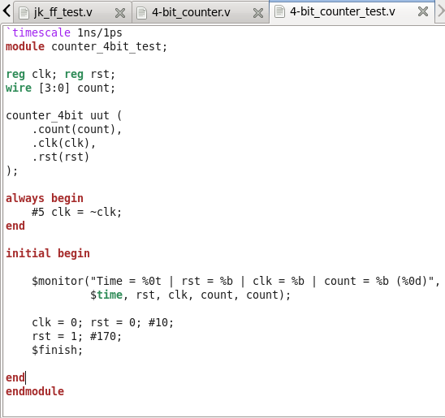

Figure-1.3. NCLaunch window of 4-bit Counter showing successful compilation (no errors in the Command Entry Window)
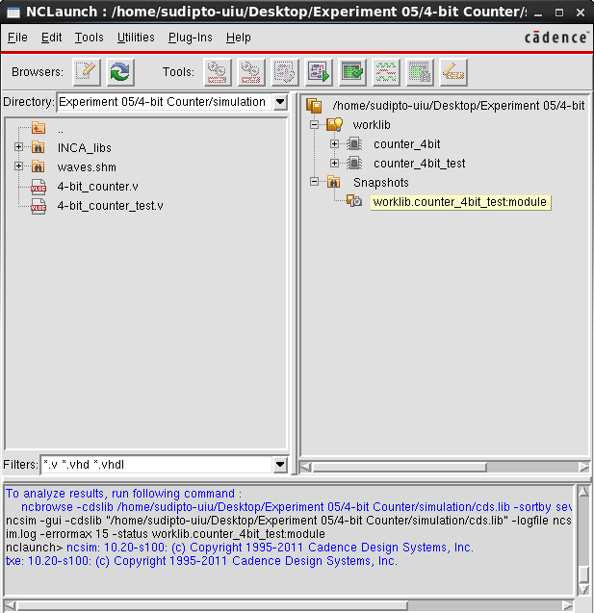

Figure-1.4. SimVision window for 4-bit Counter Test-bench, showing the inputs, selector lines, and output
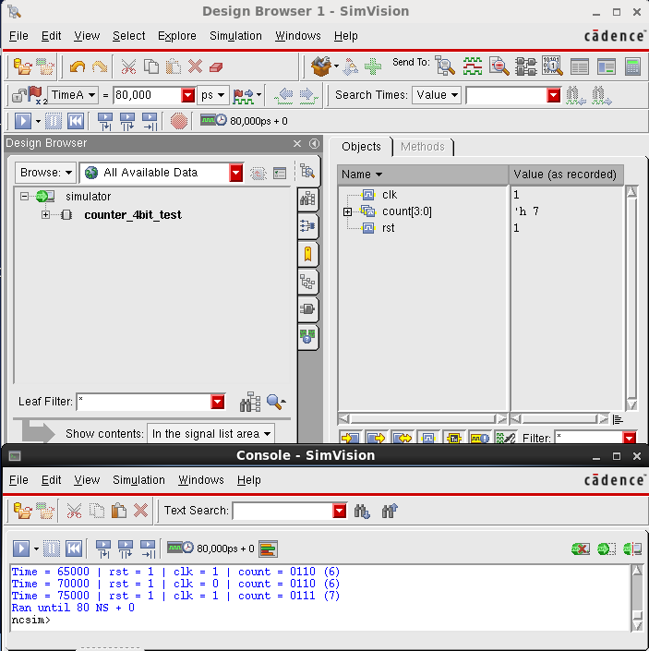

Figure-1.5. SimVision Output Waveform for 4-bit Counter Test-bench, showing the inputs, selector lines, and output
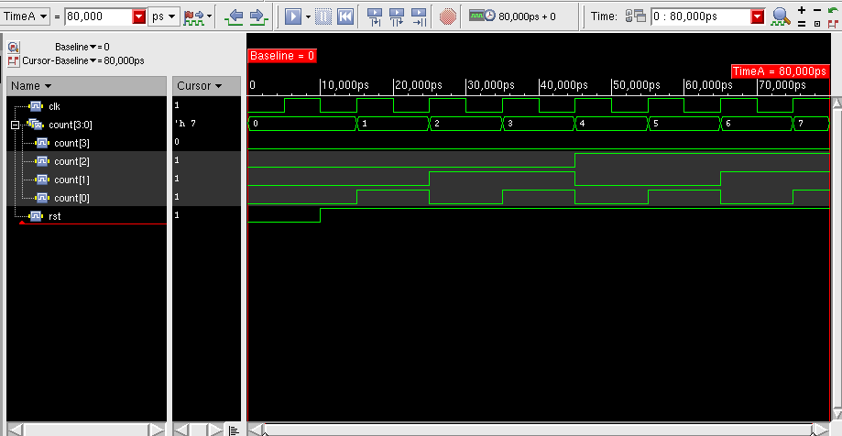

Figure-1.6. cntr4bit.g - a 10 ns clock definition, clock transition and uncertainty settings, and input/output delay constraints for rst and count.
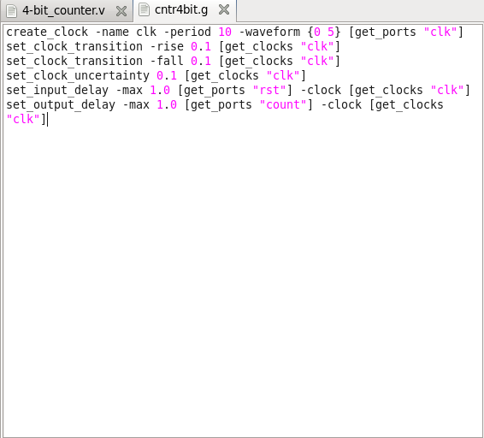

Figure-1.7. rc_script.tcl - sets the library and search paths, reads and elaborates the RTL, reads the SDC constraints, synthesizes to a mapped netlist, reports timing and power, and writes out the netlist and SDC.
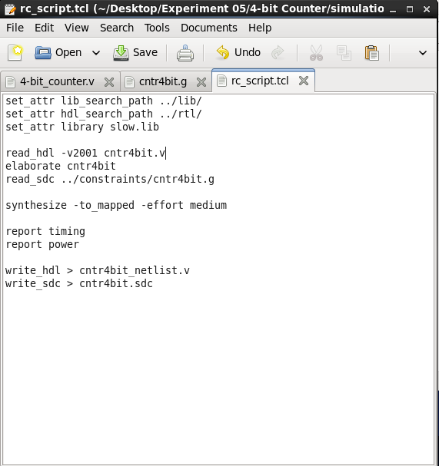

Figure-1.8. ls -lh confirming that cntr4bit.v, slow.lib, cntr4bit.g, and rc_script.tcl are all present
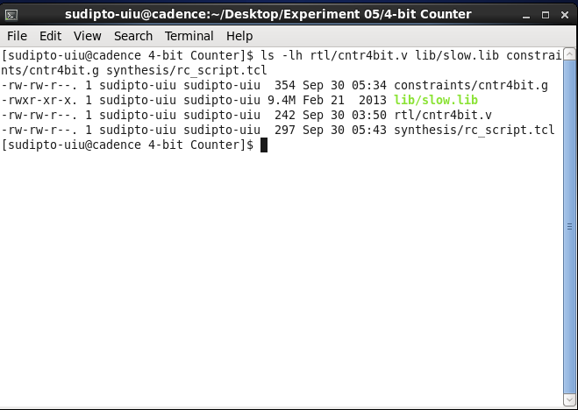

Figure-1.9. rc terminal output at the end of synthesis, showing the timing report, the power report, and confirmation that the SDC export finished
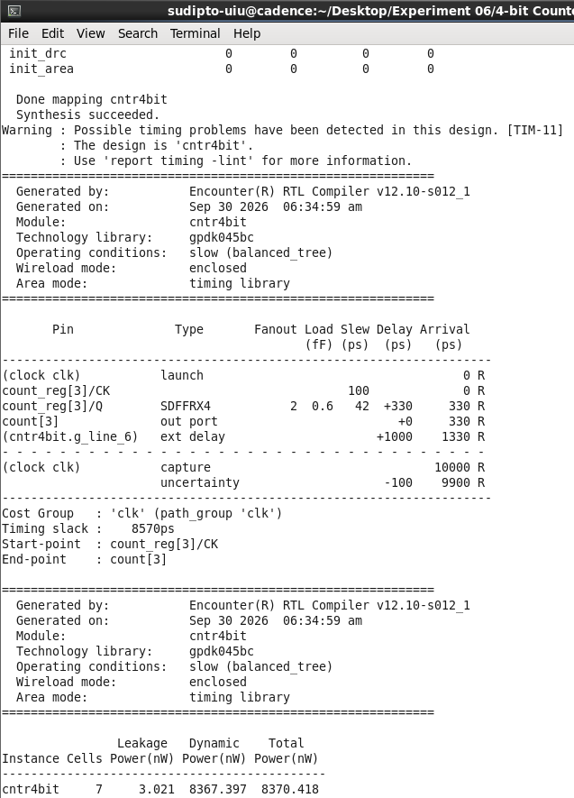

Figure-1.10. Cadence RTL Compiler schematic view of the synthesized cntr4bit design, showing the four flip-flops (DFFRX4 / DFFRHQX4 / SDFFRX4) and the gates that compute each next-state D input.
